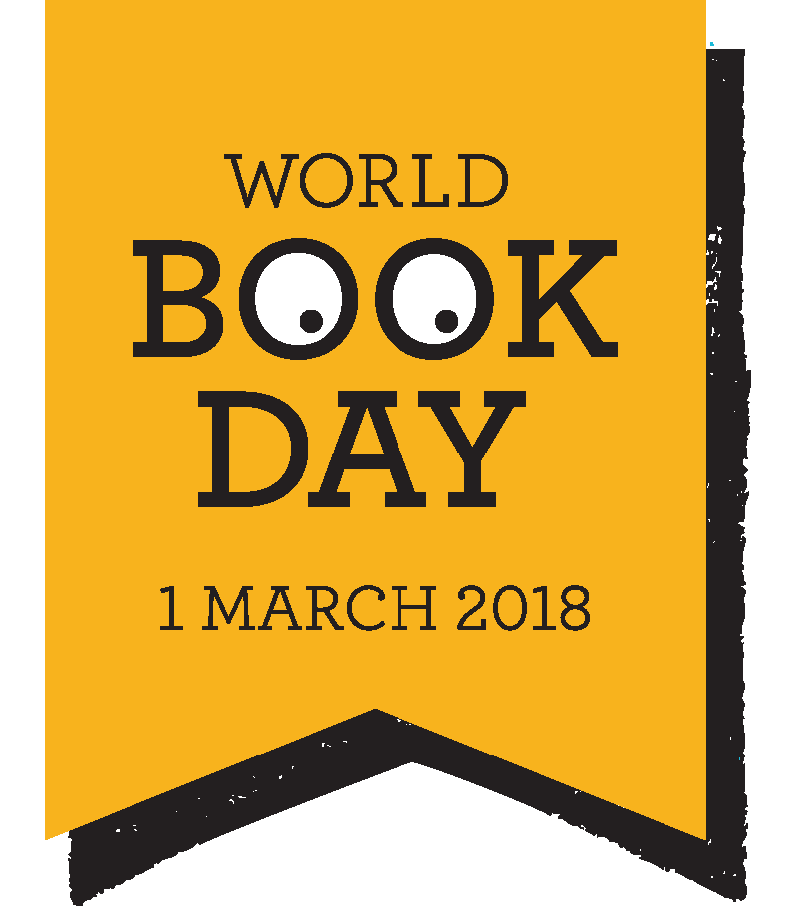
World Book Day 2018

This year we will be celebrating Word Book Day on Thursday 1st March.
Once again we are going to invite the children to dress up as a book character. We do not want this to be costly or stressful for parents. The children may already have a story character costume in their dressing up box or they may have a onesie that can be linked to a story. For the more adventurous of you there are lots of ideas for simple homemade costumes on the internet – google World Book Day costumes and lots of ideas appear. Pinterest has lots of ideas as does www.bookaid.org/world-book-day, however they do encourage you to make a donation when using this website. We would like to ask the children to bring £1 donation, we will send the collection to Book Aid International.
For parts of the day we will be celebrating the 120th birthday of C.S. Lewis and ‘The Chronicles of Narnia’. The PFA are going to be organising a quiz for the children to complete around school.
With this theme in mind the children may want to base their costume on a character from one of the stories by C. S. Lewis but they don’t have to.
We are inviting parents to come into school to join us for a picnic lunch and then activities in the classroom.
The children will be able to order a school picnic lunch (menu details to follow) and parents can bring their own picnic lunch to eat in the hall with the children. The PFA will then provide refreshments in America classroom for parents while the children have their lunchtime play.
In the afternoon we will organise the children into family groups so that parents can work with all their children to complete a creative activity. If you are able to join us for lunch and the activity afternoon then it will be lovely to see you. If you can only manage part of the day then that is fine too.
The PFA will also be organising a ‘book swap’ on World Book Day.
The following week is the Book Fair (Monday 5th – Friday 9th March) – look out for World Book Day £1 vouchers and Book Fair leaflets that will follow in book bags.
Hopefully we have given you enough notice to get your thinking caps on.

